**ONLINE HOME SERVICES PORTAL**

**An Engineering Project in Community Service**

**Final Report**

***Submitted by***

**20BHI10033 Shivam Sharma**

**20BAI10085 Ayush Porwal**

**20BAI10299 Rushil Bhatnagar**

**20BAI10327 Yashaswi Patel**

**20BCE10498 Drishtavya Gupta**

**20BCE10845 Akshat Dadhich**

**20BCE10892 Deepanshu Pandey**

**20BCY10197 Aayushi Srivastava**

***in partial fulfilment of the requirements for the degree of***

***Bachelor of Engineering and Technology***



**VIT Bhopal University**

**Bhopal**

**Madhya Pradesh**

**May 2023**



**Bonafide Certificate**

Certified that this project report titled **“ONLINE HOME SERVICES PORTAL”** is the bonafide work of “20BHI10033 Shivam Sharma, 20BAI10085 Ayush Porwal, 20BAI10299 Rushil Bhatnagar, 20BAI10327 Yashaswi Patel, 20BCE10498 Drishtavya Gupta, 20BCE10845 Akshat Dadhich, 20BCE10892 Deepanshu Pandey, 20BCY10197 Aayushi Srivastava**”** who carried out the project work under my supervision.

This project report (Final) is submitted for the Project Viva-Voce examination held on

12th May 2023.

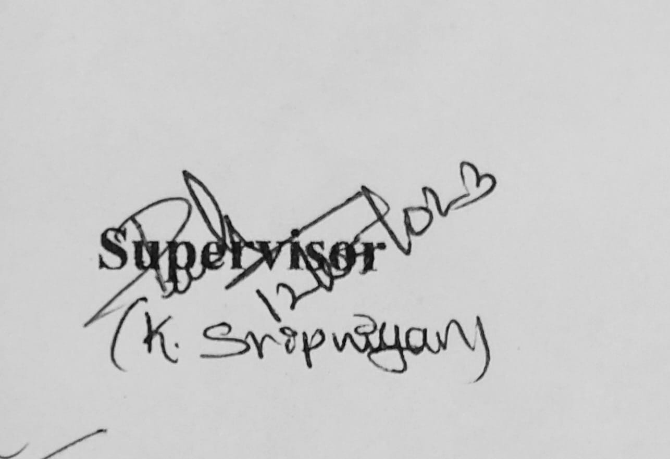

**Supervisor**

**K. Sripriyan**

***School of Mechanical Engineering***

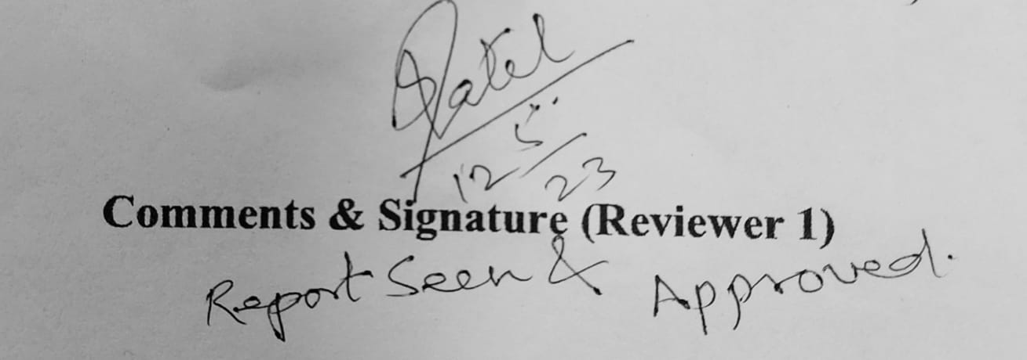

**Reviewer**

**Pradeep Kumar Kashyap**

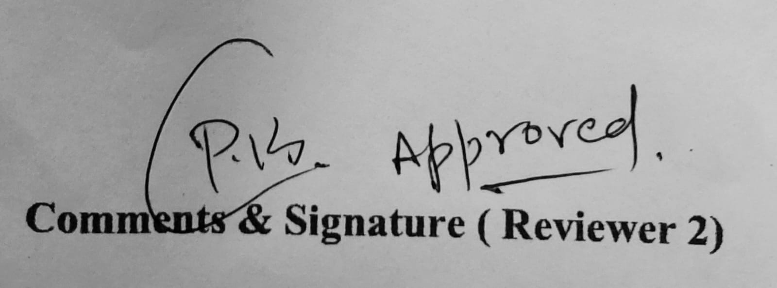

**Reviewer**

**Subhash Chandra Patel**

**.**

**LIST OF FIGURES AND GRAPHS**

| **FIGURE NO** | **TITLE** | **PAGE NO** |
| --- | --- | --- |
| 1 | Sequence Diagram | 10 |
| 2 | Use Case Diagram - Admin | 11 |
| 3 | Use Case Diagram - User | 12 |
| 4 | First Level Data Flow Diagram | 13 |
| 5 | Data Flow Diagram | 13 |
| 6 | ER Diagram | 14 |
| 7 | Activity Diagram | 15 |
| 8 | Home Page | 16 |
| 9 | Register Portal | 17 |
| 10 | Login Portal | 18 |
| 11 | Servicemen Portal | 18 |
| 12 | Customer Account | 19 |
| 13 | User Portal | 19 |
| 14 | Customer Profile | 20 |
| 15 | Admin Home Page | 20 |
| 16 | Add/Remove Servicemen | 21 |
| 17 | Add Service | 22 |
| 18 | Add City | 22 |
| 19 | Admin - View Order | 23 |
| 20 | Admin - Message read/unread | 23 |
| 21 | Admin Search Bar | 24 |
| 22 | Change/Update Password | 24 |
| 23 | Servicemen Account | 25 |

**ABSTRACT**

In emerging nations, especially India, a sizable chunk of the workforce is employed in the unorganised sector. The informal labour market is a significant area of the Indian economy. The country's unemployment rate is rising because it is challenging for workers from different parts of the nation to contact businesses or entrepreneurs about jobs outside their state or residence. In these situations, e-commerce is vital to modern living because it improves the convenience of people's daily lives and provides a number of other advantages. By considering that aspect of life, a system that can be designed and created to deliver a variety of services to your door with just a single click can be created. a system that provides a variety of services, such as laundry, plumbers, painters, repair specialists, cleaners, electricians, and movers. To make it convenient for all users, our system provides a mobile environment that makes it easy for users to access our services.

So, in the quest for employment opportunities, they get in touch with labour developers who profit from their predicament by taking a portion of their salaries as a commission to connect them. Thus, we advocate a web portal with a job recommender system to link unorganised workers with businesses and help them discover the ideal position. This idea will address the challenges that unorganised employees face in finding informal employment, link unskilled labourers across the country for employment without any commission, and result in beneficial changes to the employment rate.

**Key Words: Unorganised sector, Job portal, Job Recommender System, unskilled labourers**

**TABLE OF CONTENTS**

| **CHAPTER NO.** | **TITLE** | **PAGE NO.** |
| --- | --- | --- |
|  | Bonafide Certificate  List of Diagrams and Graphs  Abstract |  |
| **1** | **INTRODUCTION**  1.1 Motivation  1.2 Objective | 6  7 |
| **2** | **EXISTING WORK/ LITERATURE REVIEW** | 8 |
| **3** | **HARDWARE AND SOFTWARE REQUIREMENTS**  3.1 Software Requirements  3.2 Hardware Requirements | 9 |
| **4** | **SYSTEM OVERVIEW**  4.1 Admin Module  4.2 Servicemen Module  4.3 User Module | 10 |
| **5** | **SYSTEM DESIGN**  5.1 Sequence Diagram  5.2 Use Case Diagram  5.3 Data Flow Diagram  5.4 ER Diagram  5.5 Working Principal  5.5 Individual Contribution  5.6 Results | 10  10  11  13  14  15  16  16 |
| **6** | **CONCLUSIONS** | 25 |
| **7.** | **FUTURE SCOPE** | 26 |
|  | References | 27 |

# INTRODUCTION

Job Portals have been prominent for a long time. It is a preferred method for bringing together job seekers and businesses in the modern era is an online job portal. In order to find the greatest employment for them, job seekers can use a job portal. For skilled workers, there are numerous platforms where they can submit their resumes, look for jobs, and improve their abilities by posting updates, learning about various job seekers, and building a community where they can connect and share.

However, for those people who we need in our day-to-day lives like (carpenters, cabdriver, plumbers, cleaners etc), we book them with online brokers sites that cover a large number of cities and send their 4-5 people associated with them for that particular area ) to complete such tasks.

The unorganised sector forms a significant portion of the workforce in developing countries, particularly in India. One of the important sector of the Indian economy is the informal labour market. It is difficult for workers from various regions of the country to contact industry or entrepreneurs for jobs that are far from their state/settlement, which causes an increase in the country's unemployment rate. So, in search of job opportunities, they contact labour developers who take some of their wages as a commission to link them up. In this paper, we propose a web portal with a job recommender system to connect unorganised workers to their employers and find the right job.

We propose a project to cater for the needs of such individuals looking for part-time, on-demand jobs that a person needs in their day-to-day lives. The problem is opportunities and we are going to put these local experts in our portal ( upon verification) where they will get bookings from all customers in their nearby area that will use our portal.

## 1.1 Motivation

We require service providers like plumbers, cleaners, carpenters, and other home services because it occurs so frequently in our daily lives. Most likely, people manually obtain these services or make reservations through websites that do so, but only in a few cities and with a small workforce.

However, there are a lot of people in our area who need these job opportunities and will work for less money than you would pay a company to complete the task. These individuals require a platform where they can receive fair and prompt bookings in order to connect directly with the customers. This is what we intend for our project to accomplish.

## Objective

The primary topic of this report is the online system for household services, which aims to provide home services with just one click at the doorstep. The report examines the various services offered by the online system and how these services are ordered and delivered. To access the online system, users need to register with their credentials, which are authenticated and authorized, providing a secure login module for service seekers, service providers, and admin.

The online system can be accessed through a web-based platform or a mobile application, providing users with the convenience of accessing home services from anywhere and at any time. The mobile application is designed to have an interactive user interface, making it easier for users to seek services while on the go.

To ensure the users' satisfaction, the system acknowledges the confirmation of services opted by the users, making the process transparent and reliable. The ultimate goal of the online system is to provide a hassle-free experience for users who are looking for home services.

# EXISTING WORK / LITERATURE SURVEY

1. Linkedin - LinkedIn is a professional networking platform that is primarily used by professionals to connect with other professionals, find job opportunities, and build their professional reputation. It is not typically used as a platform to find unskilled labour or to advertise unskilled labour positions.

Unskilled labour positions, such as entry-level or part-time jobs, are often advertised on job boards or through local classifieds or recruitment agencies. These types of positions may not be as suitable for LinkedIn, which is geared towards more professional and skilled roles.

In addition, LinkedIn is primarily used by professionals to connect with others in their industry or field, rather than by employers looking to hire unskilled labour. As such, it may not be the most effective platform for finding unskilled labour positions.

1. Indeed - Indeed is a job search website that allows job seekers to search for job openings and companies to post job openings. What it lacks is job openings for unskilled or unorganised labour, there might be some roles available there like a receptionist or a cleaner but other jobs in the niche are not posted there hence making it almost a useless place for unskilled labour hiring.

90 percent of the 50 crore workers who work in both organised and unorganised sectors are unorganised. In terms of regulation with employers, overtime, exploitation, casual work culture, and many other issues, this unorganised sector faces numerous difficulties and challenges. Currently, industries use labour brokers to locate unskilled labourers; in return for putting the two together, they pay a commission based on the wages of these workers.

There are many job portals that facilitate direct communication between employees and employers by posting job openings etc. The employee only needs to enter his or her degree, experience, prior employment information, skills, and so forth. However, unorganised workers who lack a degree corresponding to their skills, like technicians, plumbers, joiners, and painters, cannot access such facilities.

In their article, A. Muthusamy and Dr. M. Syed Ibrahim discuss the various difficulties that unskilled workers encounter, including transportation, a lack of electronics, social standing, lower pay, unfavourable working conditions, and more. Since there are fewer employment opportunities in their area, unemployed workers find it challenging to relocate from a region to another in search of employment. They struggle to find employment in their field because the type of work they do depends on their family history. Unskilled labourers will therefore be able to connect with potential clients in their immediate area by using a job website to help them find positions that interest them.

# HARDWARE AND SOFTWARE REQUIREMENTS

**3.1 Software Requirements**

* Technology: Python Django
* IDE: Pycharm/Atom
* Client Side Technologies: HTML, CSS, JavaScript, Bootstrap
* Server Side Technologies: Python
* Database Server: Sqlite
* Operating System: Microsoft Windows/Linux

**3.2 Hardware Requirements**

* Processor: Pentium-III (or) Higher
* Ram: 64MB (or) Higher
* Hard disk: 80GB (or) Higher

1. **SYSTEM OVERVIEW**

The key features that are required in the system are as follows:

**4.1 Admin Module**

•Manage Servicemen

•Manage Users

•Manage Bookings

**4.2 Servicemen Module**

•Create Profile/Edit Profile

•View Bookings

**4.3 User Modules**

•Search Servicemen

•View Servicemen Profiles

•Book Servicemen

1. **SYSTEM DESIGN**

**5.1 Sequence Diagram**

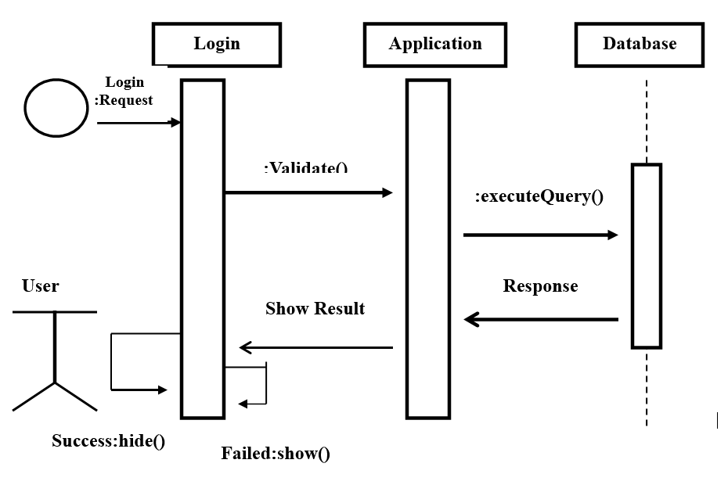

**Fig 1 Sequence Diagram**

Before logging into the portal, all users, including customers, employees, and administrators, must first authenticate themselves. The login credentials are kept in a database, and when a login request is made, the login ID and password is sent to the application layer, which then retrieves the right credentials and compares them to the ones being used. The user will be directed to the appropriate portal if their login details match, and an error message is going to appear otherwise.

**5.2 Use Case Diagram**

Use case diagram consists of use cases and actors and shows the interaction between them. The key points are:

* The main purpose is to show the interaction between the use cases and the actor.
* To represent the system requirement from the user’s perspective.
* The use cases are the functions that are to be performed in the module.
* An actor could be the end-user of the system or an external system.

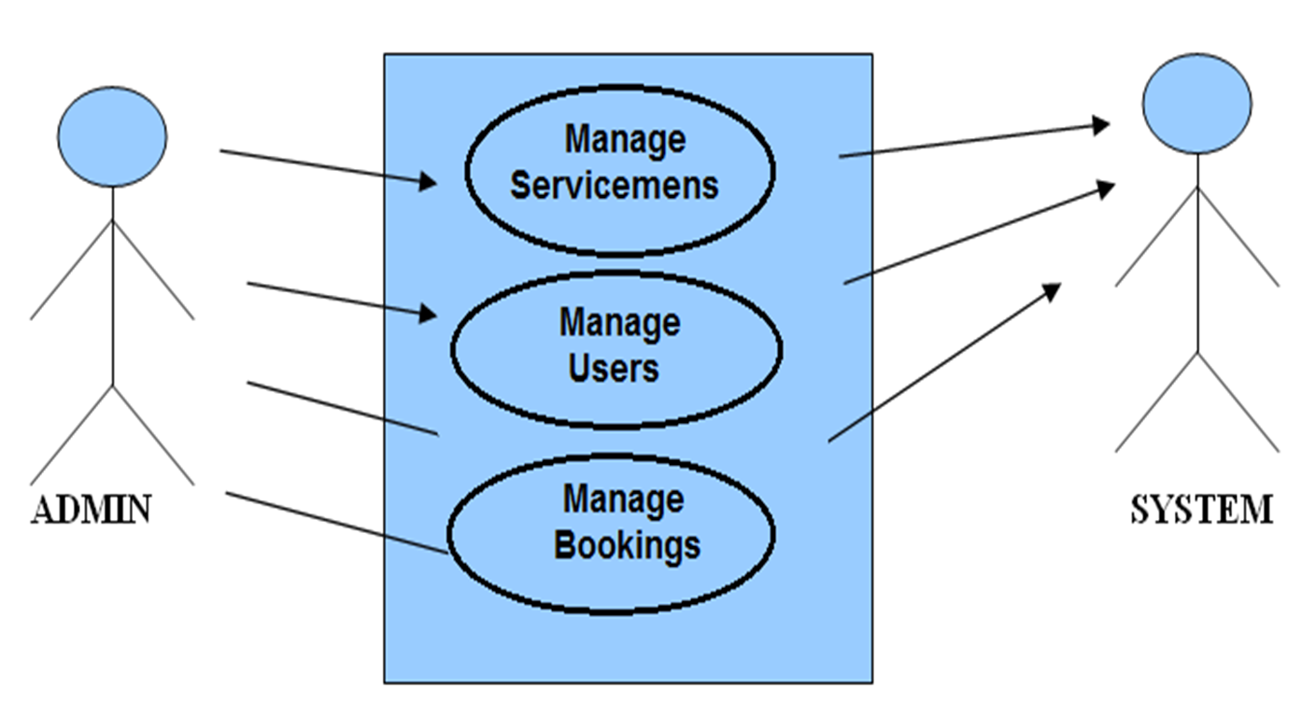

**Fig.2 Use case diagram - Admin**

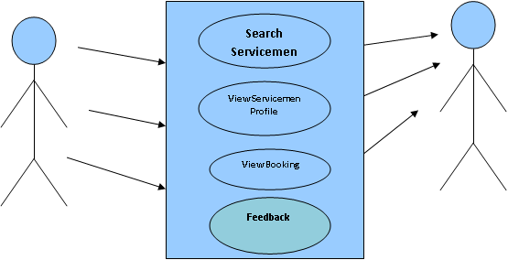

**Fig.3 Use Case Diagram - User**

The customer can :-

1. perform a location-based search for a serviceman
2. view that serviceman's profile
3. see all of his recent and past bookings
4. see whether those bookings have been accepted.

The Admin can :-

1. Manage users and customers
2. Add service categories
3. add cities
4. view customer notifications
5. and accept or reject service requests.
6. Manage servicemen, i.e., whether to add new servicemen to the portal or not.

Serviceman can :-

1. Can update his or her profile
2. Can view the bookings made
3. Can accept or reject the bookings

**5.3 Dataflow Diagram**

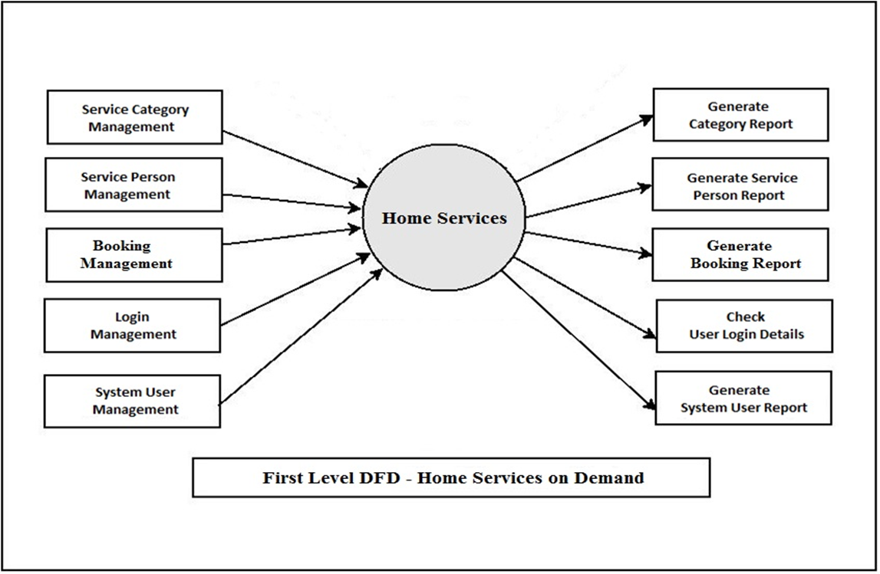

**Fig 4 First Level DFD**

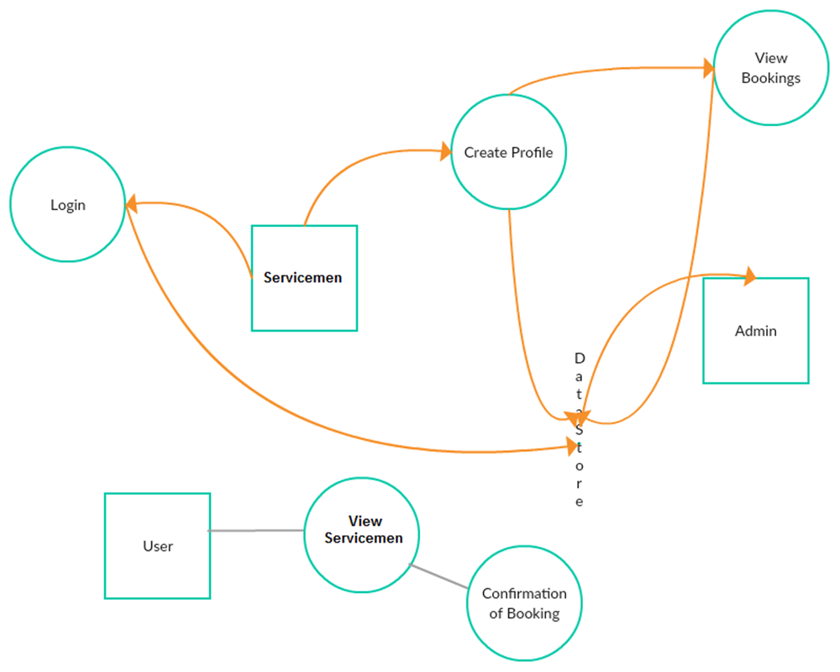

**Fig 5 Data Flow Diagram**

**5.4 ER Diagram**

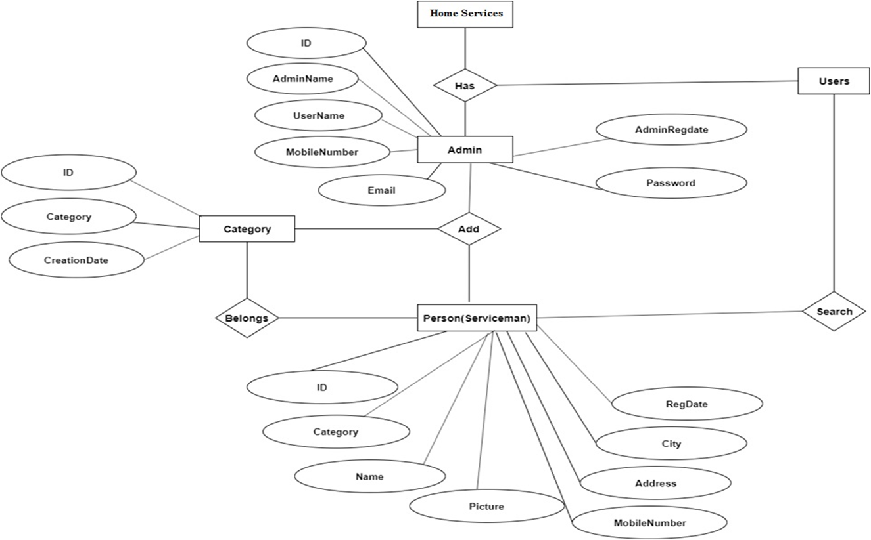

**Fig 6 ER Diagram**

**Working Principle**

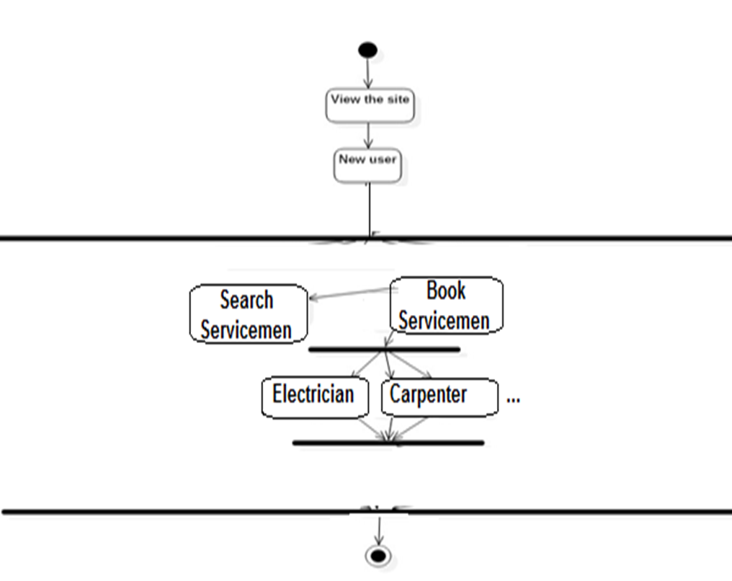

**Fig 7 Activity Diagram**

After entering the correct login information, the customer can view all the service categories the website offers, such as plumbers, contractors, electricians, etc. They can click on any of these categories to view the servicemen who are available to them, along with information about their profiles, years of experience, and locations. By filling out the form with the day and time of their visit of choice, they can reserve that serviceman. The service member will receive that request and can decide whether to approve it or not using their account.

**5.5 INDIVIDUAL CONTRIBUTION**

* I have handled the front end of the project.
* I have been responsible for designing and developing the user interface of the website. This included creating the layout, designing the pages and ensuring that the website is easy to navigate and use.
* I also tried to make sure that the website is functional and runs smoothly.
* I have contributed in the creation of profile page, home page, about page, order page, customer page, booking page, login page and city page.
* I have also contributed to Report Work for Zeroth and First Review.

**5.6 RESULT**

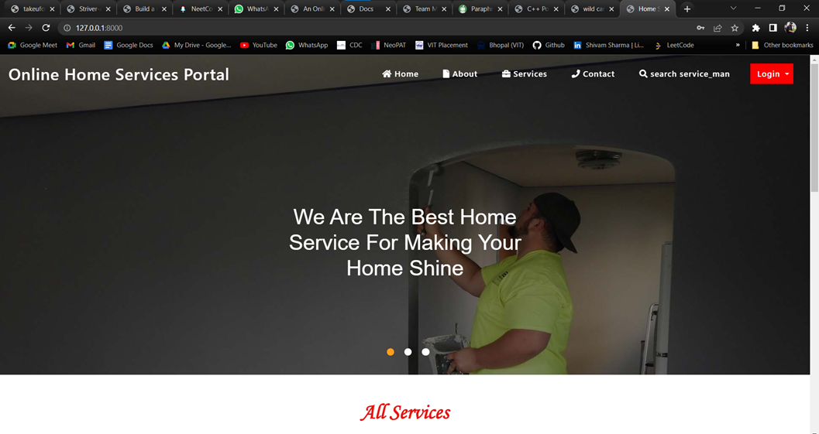

**Fig 8: Home Page**

The website's homepage allows you to view all of the services offered, get in touch with the admin using the contact form, look up service providers by location, and learn more about the site.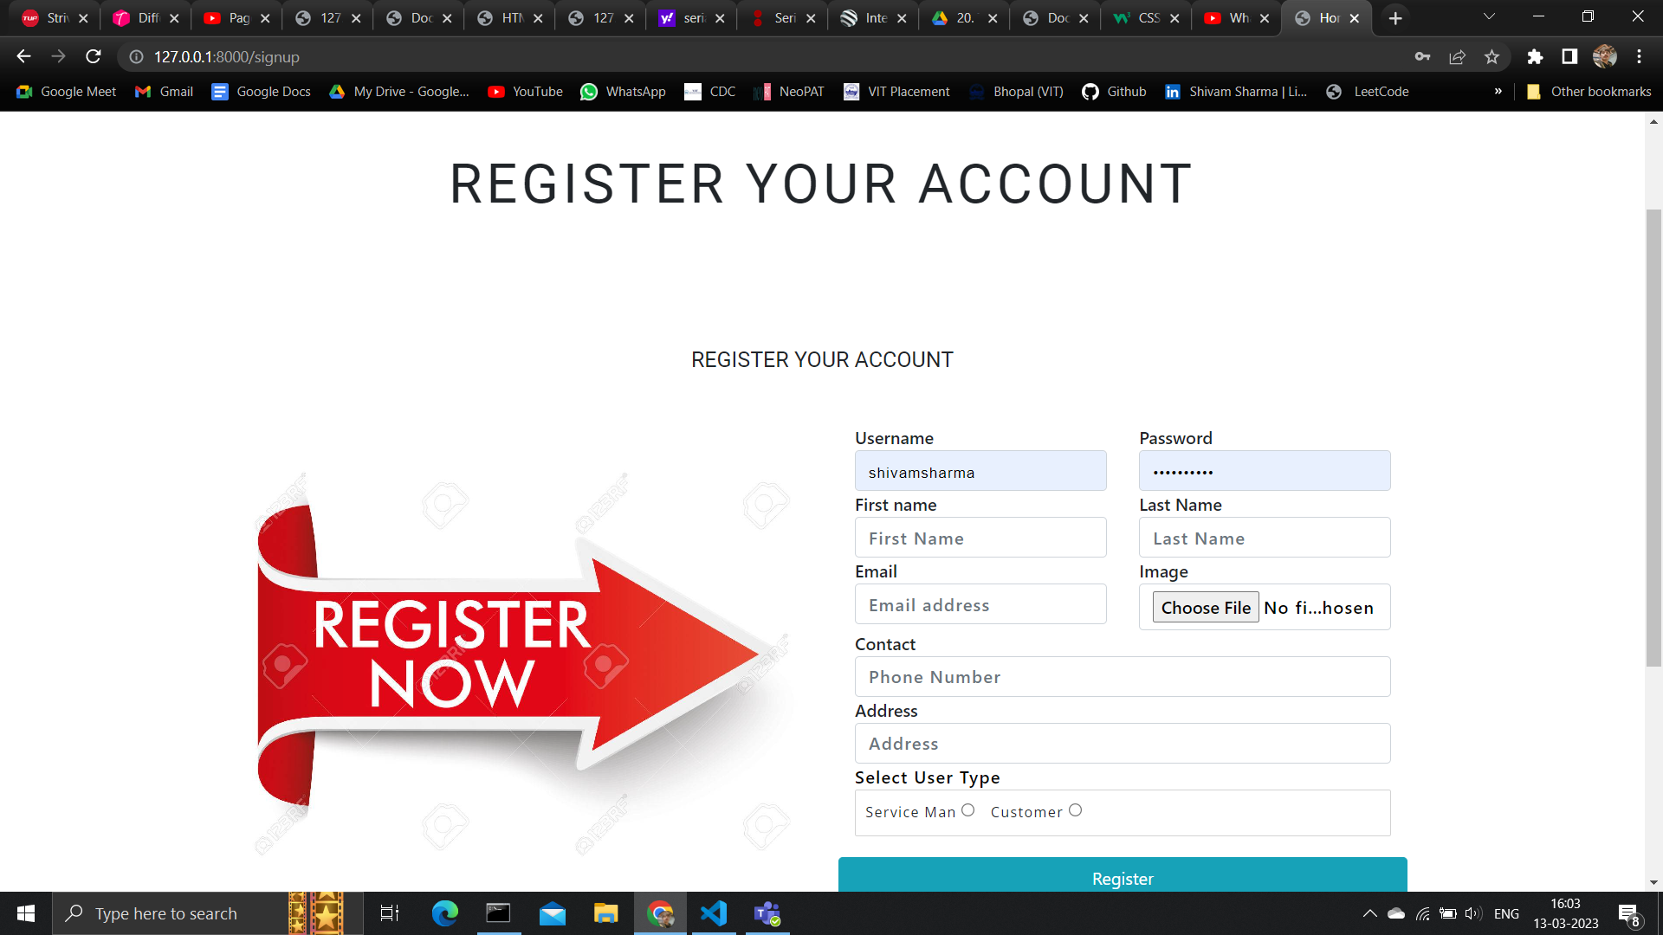

**Fig 9: Register Portal**

If you are new to the application, user needs to register in the portal only then they will be able to login into the application.

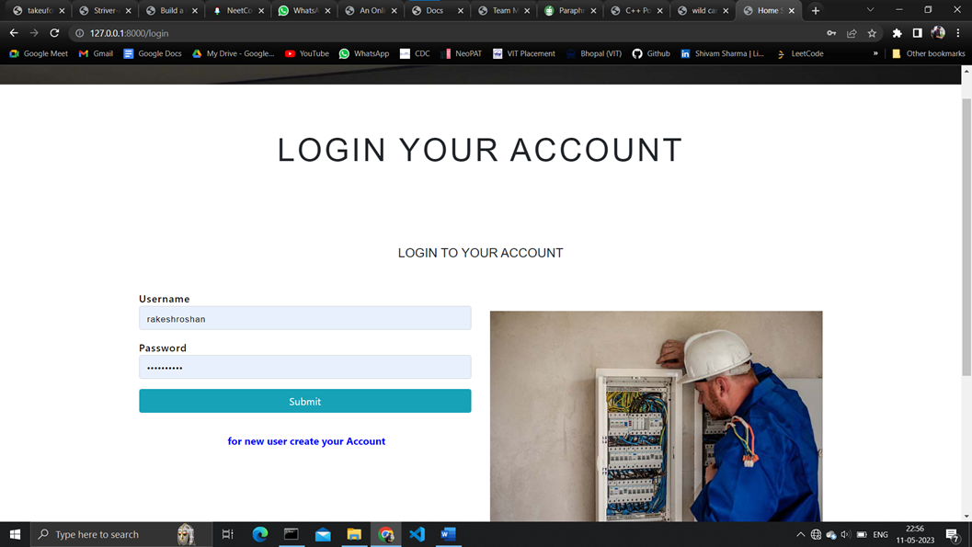

**Fig 10: Login Portal**

Before using the application, all users, including customers, employees, and administrators, must be authenticated. They can log in to the portal using this login form.

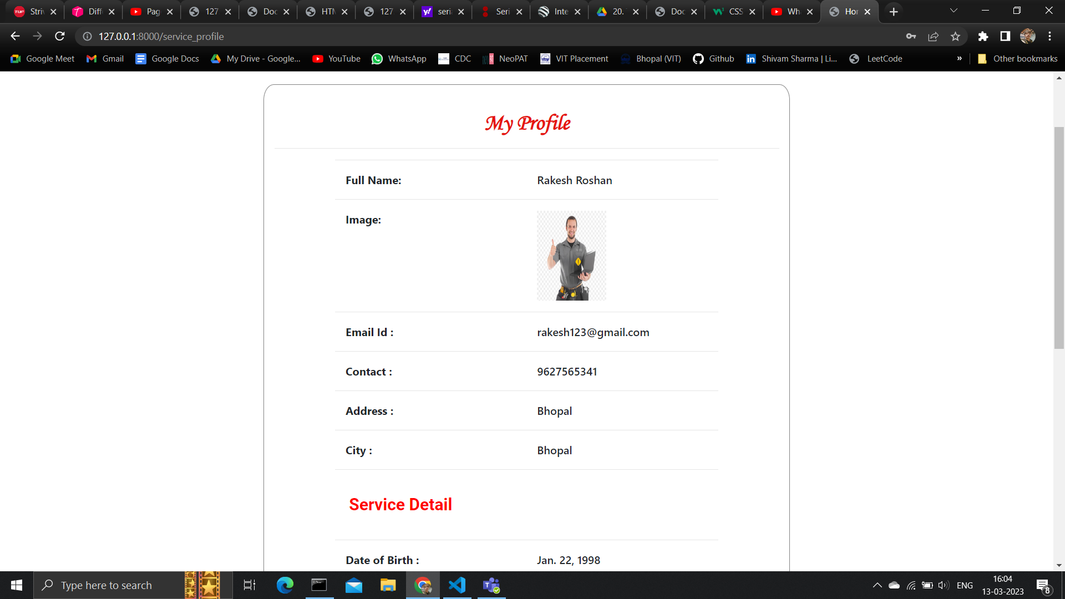

**Fig 11: Servicemen Portal**

To get information about the serviceman hired.

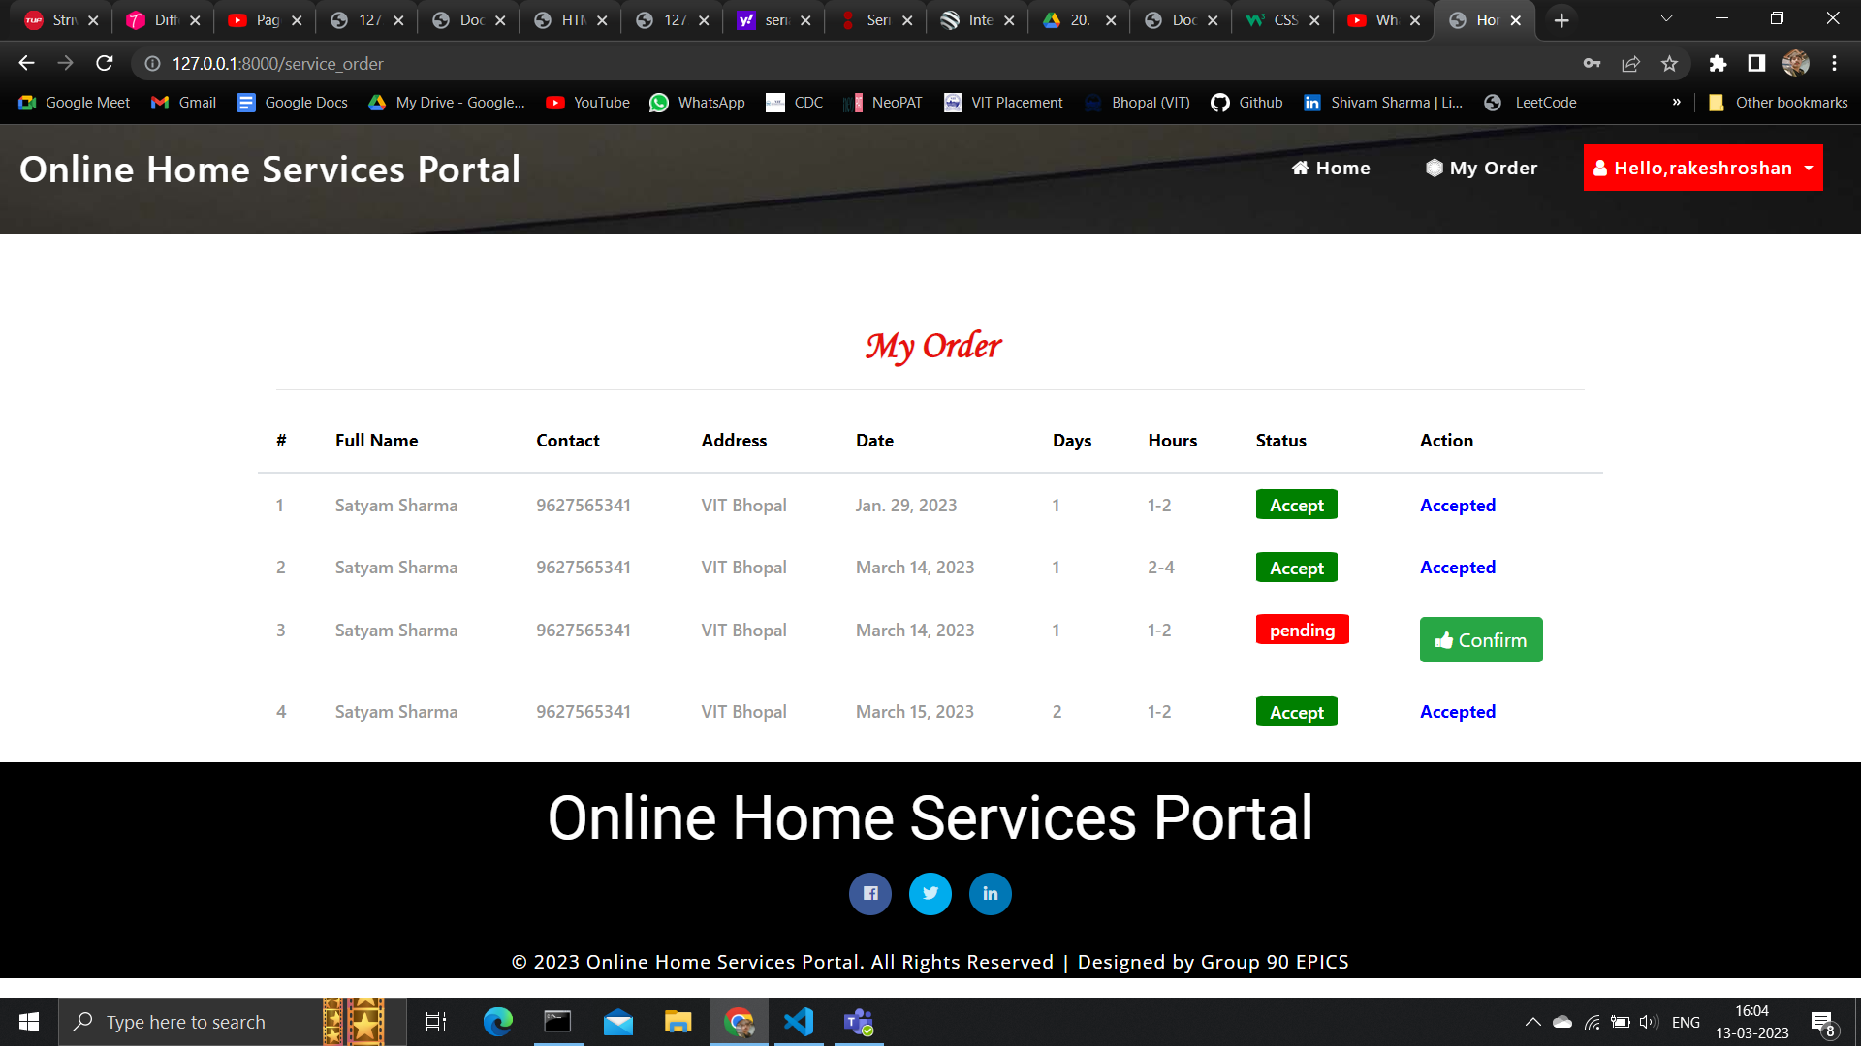

**Fig 12: Customer Account**

After logging into the portal, customer can view all their previous orders and current orders they have placed. They can also see the status of their order.

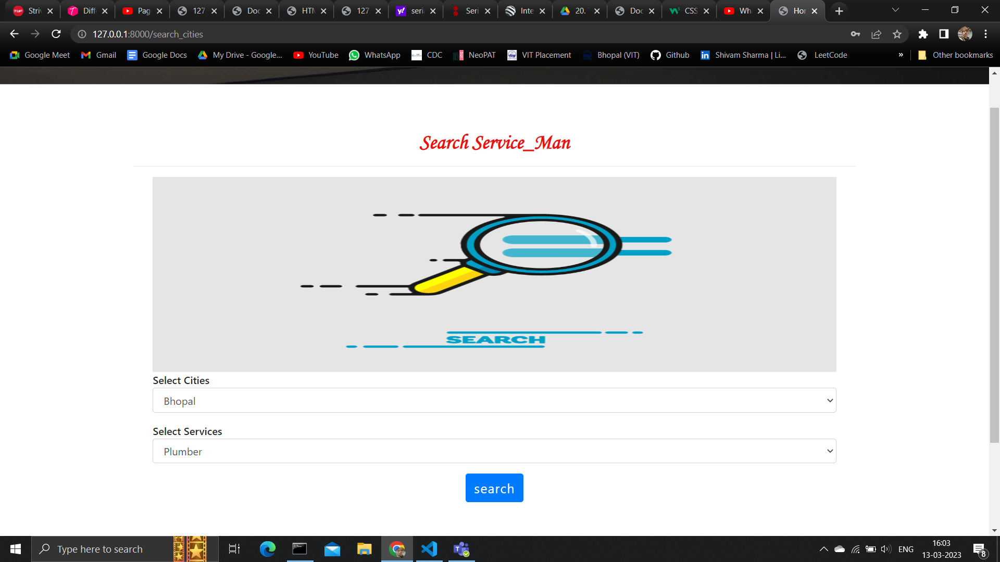

**Fig 13: User Portal**

This webpage allows the user to the search a servicemen based on service category and city.

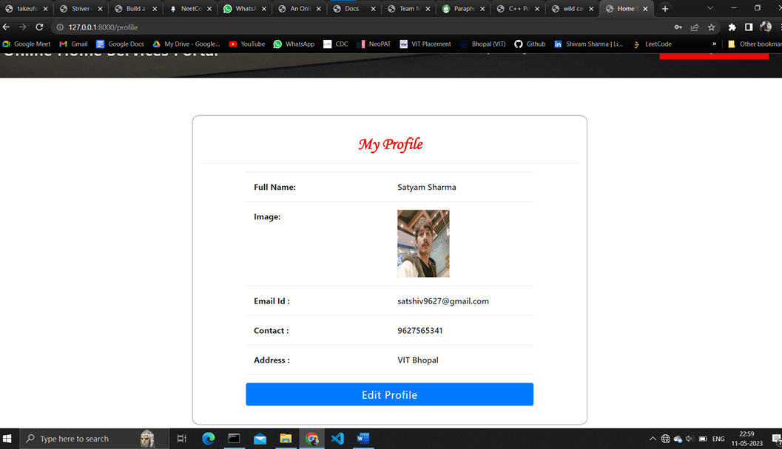

**Fig 14: Customer Profile**

This page allows the customer to edit their profile.

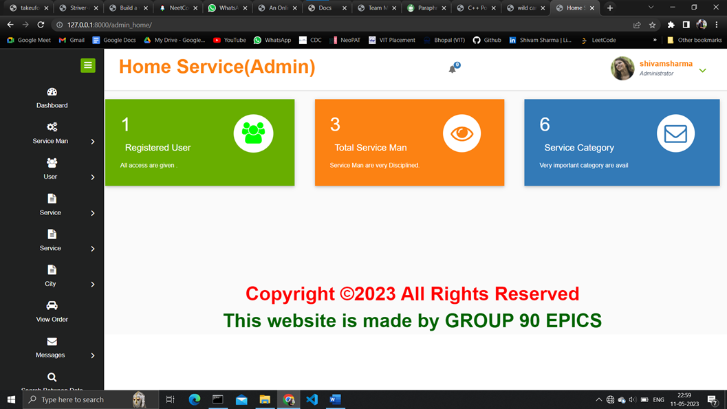

**Fig 15: Admin Home Page**

This is admin account. This account allows him to approve serviceman and create new services and add cities and see the messages and also provide the update profile option.

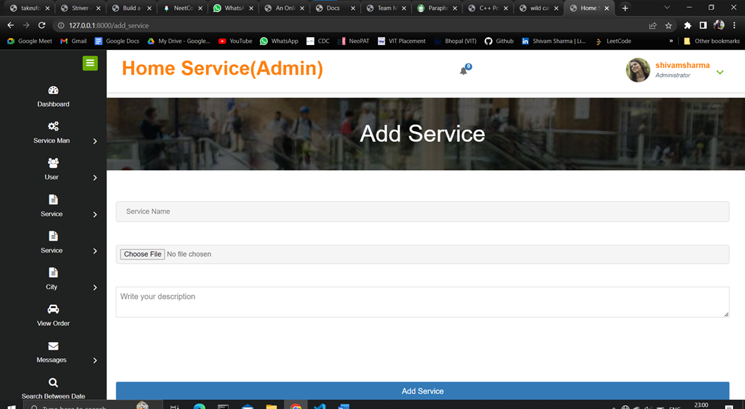

**Fig 16: Add/Remove Servicemen**

This allows admin to edit or delete servicemen.

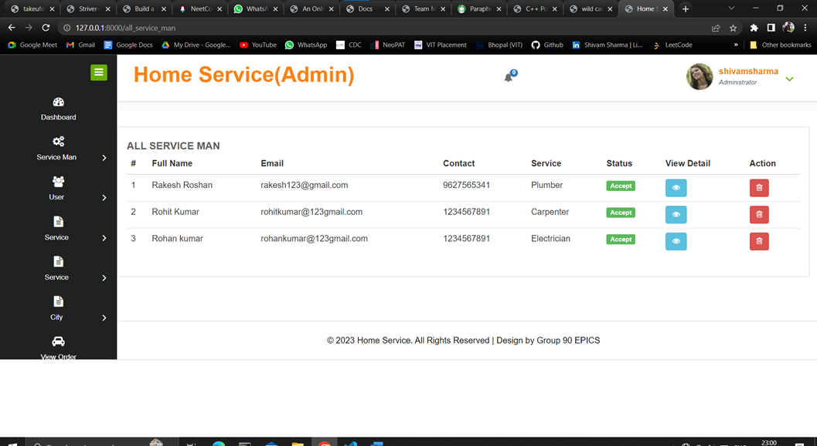

**Fig 17: Add Service**

This allows admin to add new services into the application. This improves the scalability of the application.

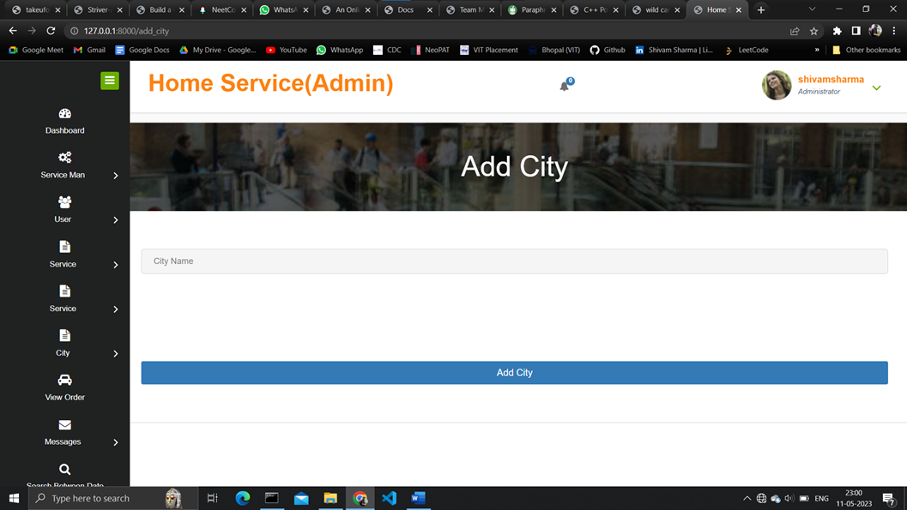

**Fig 18: Add City**

This allows admin to add cities where services and servicemen are available.

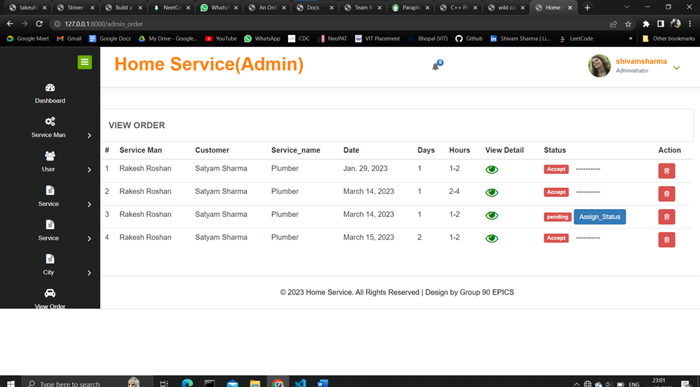

**Fig 19: Admin - View Order**

This is the administrator's webpage, where the administrator can see all the requests for servicemen made by customers and facilitates visitors to approve those requests.

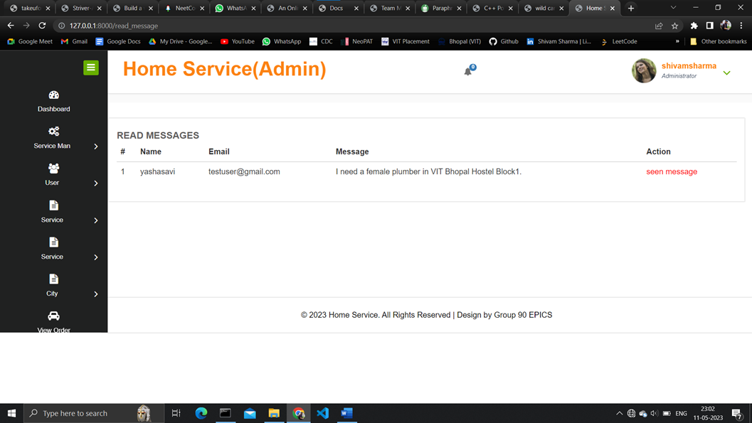

**Fig 20: Admin - Message read/unread**

To read messages made through contact form.

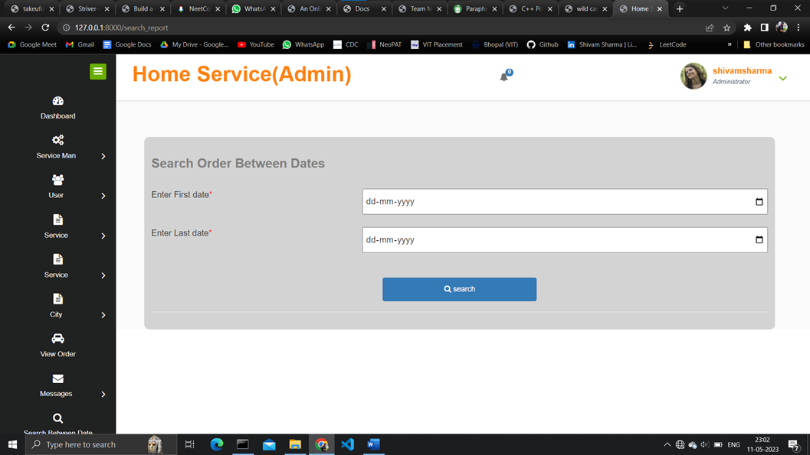

**Fig 21: Admin Search Bar**

This page allows admin to search all the orders by giving dates as input.

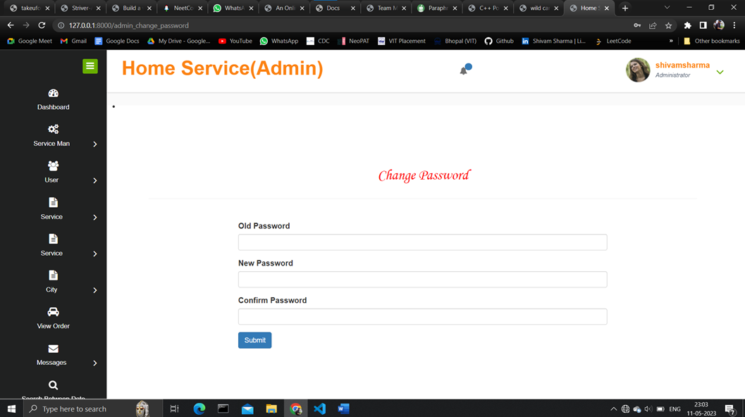

**Fig 22: Change/ Update Password**

For password updation of admin account

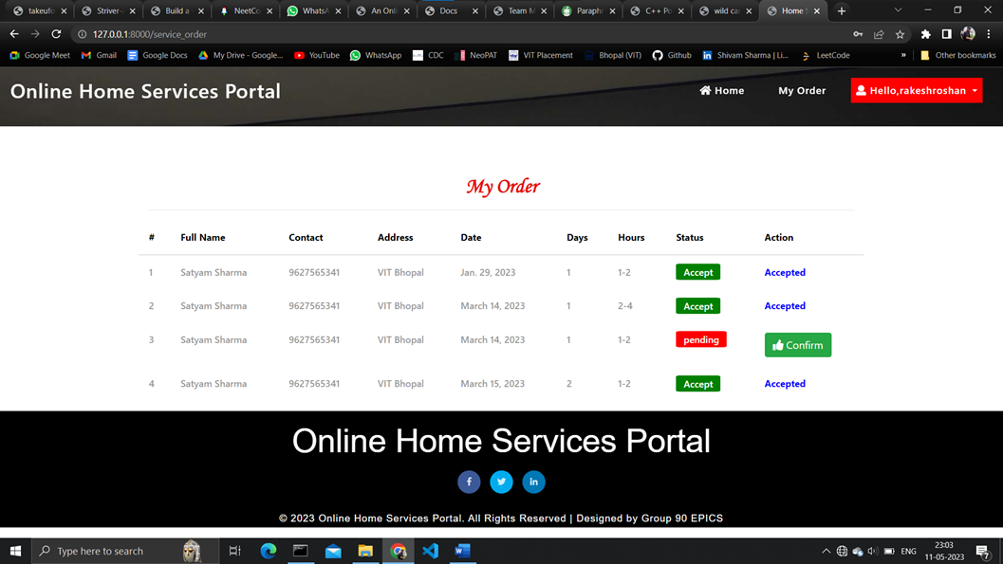

**Fig 23: Serviceman Account**

This is where all the orders can be seen that are made to that particular serviceman. The orders can be accepted after the order is generated.

# CONCLUSION

The proposed system offers several services by delivering service specialists to your doorstep in a single click, easing the burden of finding internal solutions for the services. Our services are easier to access in a more comfortable way thanks to a structured web environment for system clients. We make all of your home cleaning, plumbing, furniture maintenance, electrical works, appliance repair, house painting, vehicle service, and many other services to be done in a click anytime from anywhere as easy as possible with our well-qualified and background-demonstrated professionals.

1. **FUTURE SCOPE**

The online household services application is a flexible platform that can be customized to meet the needs of users. It currently offers a variety of services, such as home painting, cleaning, packing and moving, and plumbing. However, the application can be extended to offer additional services, such as mobile and computer repair, laundry services, catering services, and more. The application also supports a variety of payment methods, including online payments and cash payments at the door.

Here are some of the key points of the text:

* The online household services application is flexible and can be customized to meet the needs of users.

* The application currently offers a variety of services.

* The application can be extended to offer additional services.

* The application supports a variety of payment methods.

# Reference

[1] Shahrzad Shahriari, Mohammadreza Shahriari, Saeid gheiji. “ ECommerce And It Impactson Global Trend And Market”.International Journal of Research – Granthaalayah. Vol.3 (Iss.4): April, 2015.

[2] L.RichardYe, Yue Jeff Zhang, Dat-DaoNguyen, James Chiu,“Fee-based online services: Exploring consumers’willingness to pay ”. Journal of International Technologyand Information Management.

[3] Bo Zhang, Ruihan Yong, Meizi Li, Jianguo Pan, Jifeng Huanglaa, “ A Hybrid Trust Evaluation Framework for E-commerce in Online Social Network: ”. 2169-3536 (c) 2016 IEEE. Translations and content mining are permitted for academic research

[4] Chenggang Zhen,Peng Cheng. “Construction of campus trading platform based on third-party online payment ” 2nd International Conference on Industrial and Information Systems,IEEE,2010

[5] Sujit Kumar Basak,Irene Govender.“Examining the Impact of Privacy, Security, and Trust on the TAM and TTF Models for Ecommerce Consumers: A Pilot Study”,IEEE, 2009.

[6] CAl Yrnn-ping, WANG Yu-ying, “Simple Said about Online Payment Risks and Preventive Measure ”, China located International Conference on Infonnation Systems for Crisis Response and Management,IEEE,2010

[7] Dejan Kovachev and Ralf Klammadriano, “ Beyond the ClientServer Architectures: A Survey of Mobile Cloud Techniques ”,workshop on mobile computing in 2011.

[8] Teddy Mantoro, Admir Milišić, Media A. Ayu, “ Online Payment Procedure Involving Mobile Phone Network Infrastructure and Devices ”,IEEE 2010

[9] Haizheng Li and Han Zhang, “ How People Select Their Payment Methods in Online Auctions? An Exploration of eBay Transactions ” ,Proceedings of the 37th Hawaii International Conference on System Sciences – 2004.

[10] Cong Yin, “ An empirical study on users’ online payment behavior of tourism website ”,IEEE 12th International Conference on e-Business Engineering,2015.